# DBT JOBS - COST MONITORING

Monitoring DBT job cost consumption through Snowsight dashboards is crucial for effective cost management and resource optimization. Snowsight provides real-time visibility into the costs associated with running DBT jobs. You can track and analyze the cost implications of individual jobs, projects, or time periods, enabling you to identify areas of high consumption and optimize resource allocation. With Snowsight's data visualization capabilities, you can create custom metrics and visualizations specific to DBT cost monitoring. This allows you to track cost trends, compare expenses across different dimensions, and identify cost-saving opportunities.Snowsight dashboards can be shared with stakeholders, promoting transparency and collaboration. Users can access the dashboards, interact with the data, and contribute to cost optimization efforts.

With below monitoring DBT job cost consumption KPIs you will be empowered to control costs, optimize resource usage, identify cost-saving opportunities, and make data-driven decisions for efficient data transformation processes.

Best Practices:

1. Create a dedicated Service User for the DBT processes.
2. Allocate a separate warehouse for the Service User.
3. Refrain from using the compute warehouse that is assigned for DBT transformations, for any other purpose, to get an accurate insight on the credit details.

## Total Credits Consumed by All the Jobs :

SELECT

round(SUM(CREDITS_USED),3) AS total_credits_consumed

FROM

account_usage.WAREHOUSE_METERING_HISTORY

WHERE

warehouse_name = :wh_name ;



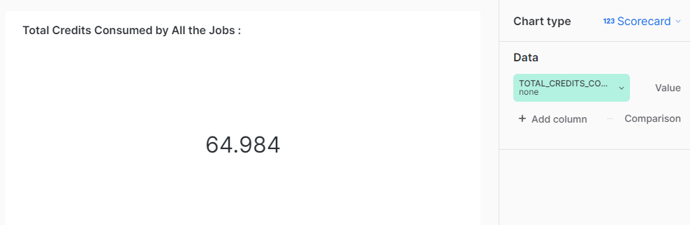

## Total Credits Charged for Cloud Usage :

SELECT

round(SUM(CREDITS_USED_CLOUD_SERVICES),3) AS total_cloud_credits_consumed

FROM

account_usage.query_history

WHERE

user_name = 'STAGE_SNOWFLAKE_DBT';



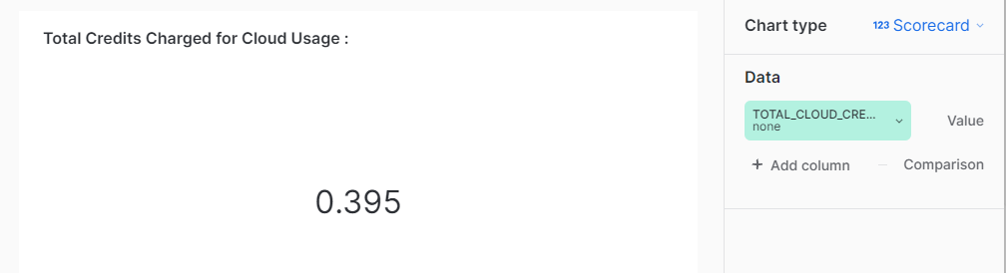

## 

## Total Credits Charged for Compute Usage :

SELECT

round(SUM(CREDITS_USED_COMPUTE),3) AS total_compute_credits_consumed

FROM

account_usage.WAREHOUSE_METERING_HISTORY

WHERE

warehouse_name = :wh_name;



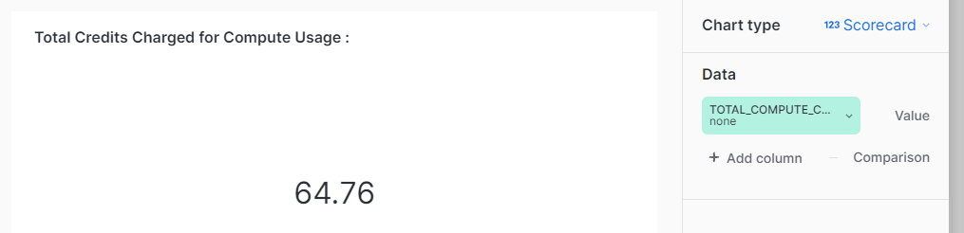

## Trend of Credit Consumption by Runs based on Warehouse usage :

SELECT

SUM(CREDITS_USED)AS total_credits_consumed,

SUM(CREDITS_USED_COMPUTE)AS total_compute_credits_consumed,

SUM(CREDITS_USED_CLOUD_SERVICES)AS total_cloud_credits_consumed,

to_date(DATE_TRUNC('week', start_time)) as day --:filter

FROM

account_usage.WAREHOUSE_METERING_HISTORY

WHERE

warehouse_name = :wh_name --:filter

group by day

order by day;



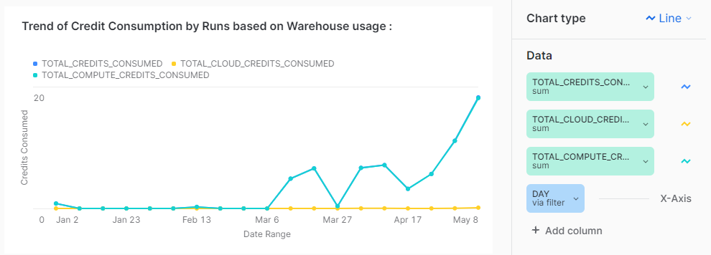

## Total Credits Consumed by Jobs based on the Warehouse:

SELECT

jla.job_name,round(sum(credits_used),3) as total_credits,

round(sum(CREDITS_USED_CLOUD_SERVICES),3) as cloud_credits,

round(sum(CREDITS_USED_COMPUTE),3) as compute_credits

FROM "ACCOUNT_USAGE"."WAREHOUSE_METERING_HISTORY" whm

JOIN

"DBT_COE"."RUNS_LIST_ATM" rla

ON

date_Trunc('hour',rla.started_At)= date_Trunc('hour',whm.start_time)

JOIN

"DBT_COE"."JOBS_LIST_ATM" jla

ON jla.job_id=rla.job_id

where

warehouse_name = :wh_name

group by jla.job_name

order by job_name desc limit 5;



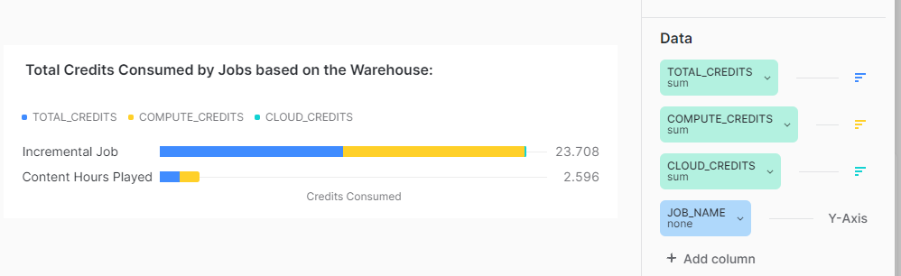

## 

## Credits Consumed based on Query Category :

SELECT sum(w.CREDITS_USED) as total_Credits , sum(w.CREDITS_USED_COMPUTE) as compute_credits, sum(w.CREDITS_USED_CLOUD_SERVICES)as cloud_credits,

CASE

WHEN lower(q.QUERY_TEXT) like '%insert%' THEN 'Ingestion'

WHEN lower(q.QUERY_TEXT) like '%copy into%' THEN 'Loading'

WHEN lower(q.QUERY_TEXT) like '%describe%' THEN 'Verify Metadata'

WHEN lower(q.QUERY_TEXT) like '%update%' THEN 'Modification'

WHEN lower(q.QUERY_TEXT) like '%select%' THEN 'Retrieval'

WHEN lower(q.QUERY_TEXT) like '%drop%' THEN 'Management'

ELSE 'Others'

END AS category

FROM ACCOUNT_USAGE.QUERY_HISTORY q

JOIN ACCOUNT_USAGE.WAREHOUSE_METERING_HISTORY w

on q. warehouse_id=w.warehouse_id

WHERE q.EXECUTION_STATUS='SUCCESS'

group by category;



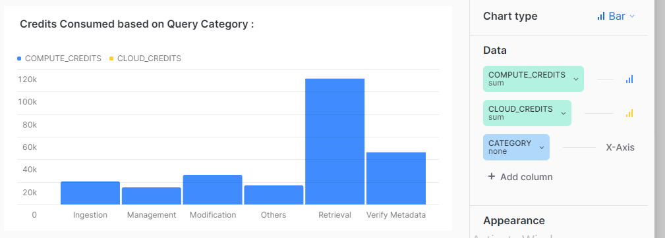

## 

## 

## 7. Top 10 Credit Consumed Runs based on Warehouse Usage :

SELECT

run_id,jla.job_name, rla.project_id, round(sum(credits_used),3) as total_credits,

round(sum(CREDITS_USED_CLOUD_SERVICES),4) as cloud_credits,

round(sum(CREDITS_USED_COMPUTE),3) as compute_credits,

start_time

FROM

"DBT_COE"."JOBS_LIST_ATM" jla

JOIN

"DBT_COE"."RUNS_LIST_ATM" rla

ON jla.job_id=rla.job_id

JOIN "ACCOUNT_USAGE"."WAREHOUSE_METERING_HISTORY" whm

ON

date_Trunc('hour',rla.started_At)= date_Trunc('hour',whm.start_time)

where warehouse_name = :wh_name

group by run_id ,jla.job_name, rla.project_id, start_time

order by total_credits desc limit 10;



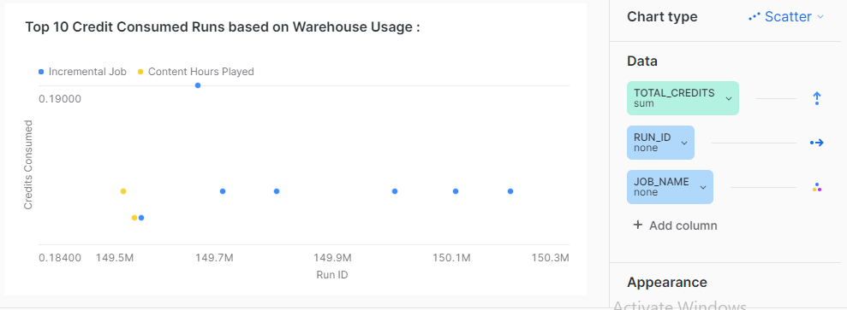

**Filters**:

1. Filter Name: Warehouse_name

Alias: :wh_name

Query:

select distinct(warehouse_name) from "ACCOUNT_USAGE"."QUERY_HISTORY";